SuMeWa|SYSTEM
General Enquiry
In order to evaluate the feasibility of implementing SuMeWa|SYSTEM at the site of interest, some basic information about this location is necessary. We kindly ask you to fill out this from as precise as possible. If possible please attach photos.

Location
Where would you like to install the SuMeWa|SYSTEM (important for us to evaluate solar radiation)?
Country:
State:
City / Village:
Whom/What would you like to supply with water from SuMeWa|SYSTEM?
 | Village |  |  |  | Refugee Camp |  |  |  |  | Children’s home
 | School |  |  |  | Other:
Number of potential users:
Site of Installation
How long would be the following distances (in meters)?
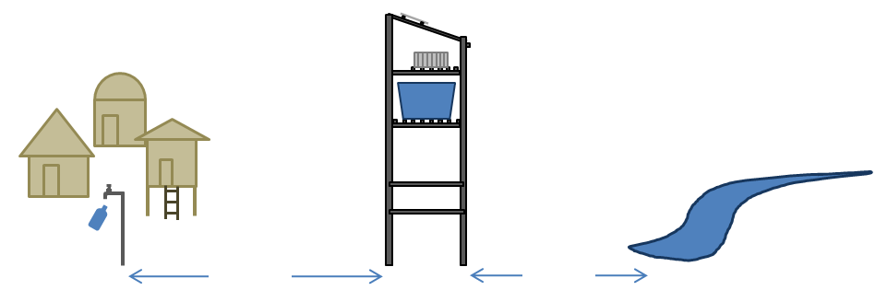
Distance between water source and site of installation:

Distance between the site of installation and tap points:
m |  |  |  |  |  |  | m
Current Water Supply
Which water source is currently used at the site of interest?
 | Lake |  |  |  | River |  |  |  |  | Open well
 | Pond |  |  |  | Creek |  |  |  |  | Closed well
 | Bottled water only
How is the water currently treated?
 | Not at all |  |  |  | Central treatment |  |  |  |  | Utilization of filters at point of use
 | Disinfection of water at point of use |  |  |  |  |  |  |  |  | Other:
Which water supply facilities are existent at the site of interest (if any)?
 | Water tanks |  |  |  | Plumbing |  |  |  |  | Supply of electrical energy
 | Other
Potential Water Sources
Which water sources are available in the close proximity, and what is their distance?
 | Lake m |  |  |  | River m |  |  |  |  |  | Open well m
 | Pond m |  |  |  | Creek m |  |  |  |  |  | Closed well m
Water Quality – standard parameters (please use a separate sheet for each potential water source)
Please indicate the clearness of the water
 | clear |  |  |  | little turbid |  |  |  |  |  | turbid
Please make a rough judgment about the water quality of the potential water source. Are sources of pollution, high iron or heavy metal concentrations, etc. known? If so please indicate:
Please indicate the following water quality parameters if possible (rapid tests are sufficient)
pH: |  |  | conductivity  [µS/cm]: |  |  |  |  | Chloride Ion conc. [mg/L]:
Further important information
Photos

