SuMeWa|SYSTEM
Specific Enquiry
Please fill out this form additionally to the general enquiry to supply us with specific information about the potential site of installation. We will process this information, to supply you with sufficient instructions on how to install the system most adequately and to ship necessary equipment. Please enclose photos if possible.

Water Quality – advanced parameters (please use a separate sheet for each pot. water source)
Microbial parameters [cfu] (please fill out if possible):
Total coliform |  |  | Fecal coliform |  |  |  |  | Intestinal enterococci
E.Coli |  |  | Cryptosporidium
Chemical / physical parameters (please fill out if possible):
Fluoride  conc. [mg/L] |  |  | Arsen  conc. [mg/L] |  |  |  |  | Iron  conc. [mg/L]
Ammonia conc. [mg/L] |  |  | Bromide conc. [mg/L] |  |  |  |  | Further known heavy metal and ion conc. [mg/L]
Turbidity [NTU]
Potential Utilization of SuMeWa|SYSTEM
What would the produced water be used for?
 | Drinking only |  |  | Drinking and cooking |  |  |  |  |  | Drinking, Cooking, and Hygiene
How would the people extract the water?
 | At the installation site via a central extraction tap
 | Central extraction tap within the dwelling/village
 | Direct taping inside each house
Sanitary facilities
What kind of sanitary facilities are present (multiple crossing possible)?
 | None |  |  |  | Lavatory |  |  |  | Pit latrine
 |  |  |  |  | Showers |  |  |  | Flush toilets
Are those supposed to be connected to the SuMeWa|SYSTEM?
 | No |  |  |  | Yes (this would reduce the qty of people supplied substantially)
Effluent disposal
How is sullage and/or sewage treated (multiple crossing possible)?
 | Not at all |  |  |  | Septic tank |  |  |  | Advanced treatment
 |  |  |  |  |  |  |  |  | Centralized discharge into open water bodies
Installation of SuMeWa|SYSTEM
To install the SuMeWa|SYSTEM, a scaffold similar to the ones shown here, needs to be constructed self directed. Are you able to install the scaffold under given local conditions self directed?
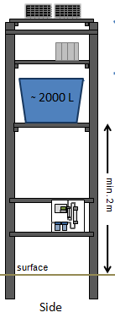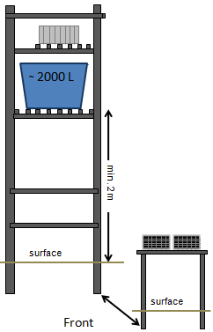 |  |  |  |  |  |  |  |  |  |  |  |  | Yes |  |  |  | No
Is it poissible to aqurie or construct at least one water tank with a volume of 1-3 m³, locally? |  |  |  |  |  |  |  |  |  |  |  |  | Yes |  |  |  | No
Is it possible to install 2 PV-Modules (~1 m²) next to/onto the scaffold without them being shaded?
 | Yes |  |  | No
When the PV-Modules are to be installed next to the scaffold (e.g. on a rooftop), how long would be the distance between both (in meters)?
How long would be the distance between scaffold and the point(s) of use (in meters)?
Further important information:

